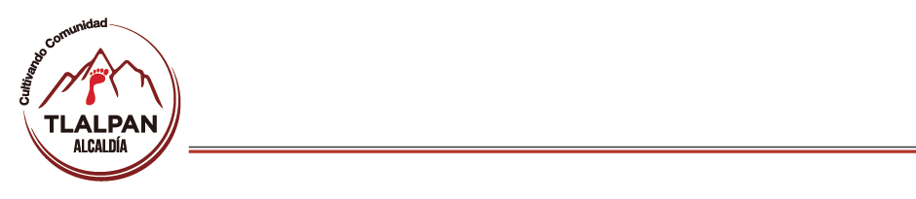

|  |  |  |  |  |  |  |  |  |  |
| --- | --- | --- | --- | --- | --- | --- | --- | --- | --- |
| MATRICULA DE ENERO 2021 | | | | | | | | | |
| CENDI | MATERNAL | | PREESCOLAR 1 | | PREESCOLAR 2 | | PREESCOLAR 3 | | TOTAL |
| NIÑAS | NIÑOS | NIÑAS | NIÑOS | NIÑAS | NIÑOS | NIÑAS | NIÑOS |
| MIGUEL HIDALGO | 4 | 9 | 6 | 5 | 11 | 3 | 6 | 4 | 48 |
| CABAÑA ENCANTADA | 3 | 12 | 7 | 11 | 8 | 12 | 18 | 20 | 91 |
| LOMAS HIDALGO | 10 | 7 | 7 | 14 | 19 | 20 | 16 | 11 | 104 |
| MIRADOR | 2 | 7 | 13 | 9 | 18 | 8 | 21 | 22 | 100 |
| VILLA COAPA | 3 | 2 | 12 | 2 | 12 | 12 | 7 | 11 | 61 |
| TOTAL | 22 | 37 | 45 | 41 | 68 | 55 | 68 | 68 | **404** |
| MATRICULA | 59 | | 86 | | 123 | | 136 | |

|  |  |
| --- | --- |
| TOTAL DE NIÑAS: **202 50**% | TOTAL DE NIÑOS: **202 50%** |

|  |  |  |  |  |  |  |  |  |  |
| --- | --- | --- | --- | --- | --- | --- | --- | --- | --- |
| MATRICULA DE FEBRERO 2021 | | | | | | | | | |
| CENDI | MATERNAL | | PREESCOLAR 1 | | PREESCOLAR 2 | | PREESCOLAR 3 | | TOTAL |
| NIÑAS | NIÑOS | NIÑAS | NIÑOS | NIÑAS | NIÑOS | NIÑAS | NIÑOS |
| MIGUEL HIDALGO | 4 | 9 | 7 | 5 | 6 | 7 | 11 | 3 | 52 |
| CABAÑA ENCANTADA | 3 | 12 | 7 | 11 | 8 | 12 | 18 | 20 | 91 |
| LOMAS HIDALGO | 10 | 7 | 7 | 14 | 19 | 20 | 16 | 11 | 104 |
| MIRADOR | 3 | 6 | 11 | 10 | 16 | 8 | 21 | 22 | 97 |
| VILLA COAPA | 3 | 2 | 12 | 2 | 12 | 12 | 7 | 11 | 61 |
| TOTAL | 23 | 36 | 44 | 42 | 61 | 59 | 73 | 67 | **405** |
| MATRICULA | 59 | | 86 | | 120 | | 140 | |

|  |  |
| --- | --- |
| TOTAL DE NIÑAS: **201 49.6** | TOTAL DE NIÑOS: **204 50.4%** |

|  |  |  |  |  |  |  |  |  |  |
| --- | --- | --- | --- | --- | --- | --- | --- | --- | --- |
| MATRICULA DE MARZO 2021 | | | | | | | | | |
| CENDI | MATERNAL | | PREESCOLAR 1 | | PREESCOLAR 2 | | PREESCOLAR 3 | | TOTAL |
| NIÑAS | NIÑOS | NIÑAS | NIÑOS | NIÑAS | NIÑOS | NIÑAS | NIÑOS |
| MIGUEL HIDALGO | 9 | 4 | 7 | 5 | 6 | 7 | 3 | 11 | 52 |
| CABAÑA ENCANTADA | 3 | 12 | 7 | 11 | 8 | 12 | 18 | 20 | 91 |
| LOMAS HIDALGO | 10 | 7 | 7 | 14 | 19 | 20 | 16 | 11 | 104 |
| MIRADOR | 3 | 6 | 11 | 10 | 16 | 8 | 21 | 22 | 97 |
| VILLA COAPA | 3 | 1 | 11 | 4 | 13 | 13 | 7 | 10 | 62 |
| TOTAL | 28 | 30 | 43 | 44 | 62 | 60 | 65 | 74 | **406** |
| MATRICULA | 58 | | 87 | | 122 | | 139 | |

|  |  |
| --- | --- |
| TOTAL DE NIÑAS: **198 41.8%** | TOTAL DE NIÑOS: **208 51.2%** |